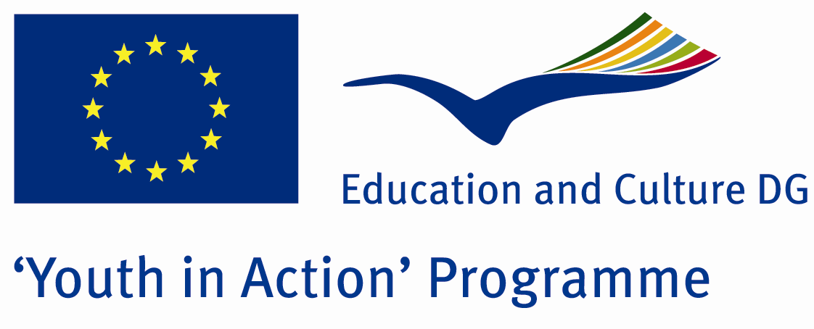

Nomad – No Land



ACTION 1.1 – Youth Exchange

08-15th August, 2011

Antalya/TURKEY

Please contact directly to;

adventurerpeacepigeons@gmail.com

Project Summary;
This project is about immigrants. People sometimes have to leave their country or region because of some reasons. For instance economic problems, social pressures, religion, wars etc. And they also face lots of problems in their new living areas. We want to talk about these problems. We want to discuss what are the problems they face with or what are the difficulties ?

Project Title; Nomad – No Land

Date and Venue ; 08-15th August, 2011 Antalya/TURKEY

Target Group; Non profit/non governmental organization, Public body, Body active at European level in the field of youth (ENGO), Informal group of young people, e.t.c…

Participants; 5 people from each country (18 - 25). Totally 8 countries.

Conditions; Accommodation, board and programme costs will be financed through European Commission Youth in Action Programme (Action 1.1). Travel costs will be reimbursed in 70% (APEX Tarrifs). Organizations from all 27 EU member countries plus Liechtenstein , Norway and Iceland are eligible to take part.

Working language: English

Organizer; Discovery And Adventure Group

How to apply: If you are interested, please send your Part III forms to
0090 216 483 21 67 by FAX please. (Fulfilled Part III which you can find in the attachment, of course signed and stamped) ..

Note: jpeg is not allowed..please send by fax…

Next step 2;
Original send via regular post to this address please:

Ertan DERİN
Öner İnşaat
Abdulhalik Renda Cd.
Parlar Sk. No:4 Pendik/İSTANBUL

If you have any questions you may contact with: adventurerpeacepigeons@gmail.com

Deadline for application; until 20th January 2011.

For Further information:
Contact Person
Ertan DERİN
Öner İnşaat
Abdulhalik Renda Cd.
Parlar Sk. No:4 Pendik/İSTANBUL

e-mail : adventurerpeacepigeons@gmail.com
Mobile : 0090 542 393 93 90
Fax : 0090 216 483 21 67

